Chapter 7, Solution 63.

For t < 0, 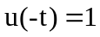, 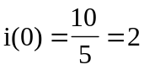

For t > 0, 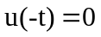, 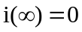
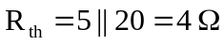, 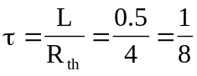
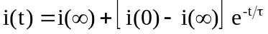

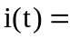2e^{–8t}u(t) A

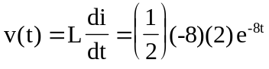

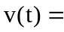–8e^{–8t}u(t) V

2e^{–8t}u(t) A, –8e^{–8t}u(t) V

